 WOODLANDS SURGERY

GROUP PRACTICE

Please keep this booklet safe for easy reference

SURGERY DETAILS

Surgery Address:

Woodlands Surgery, Telephone No: 0333 123 4203
Woodlands Terrace, Repeat Prescriptions: 01656 311010
Caerau, Maesteg Fax No: 01656 734311
CF34 0SR


www.woodlandssurgerymaesteg.co.uk



Woodlands Surgery Maesteg

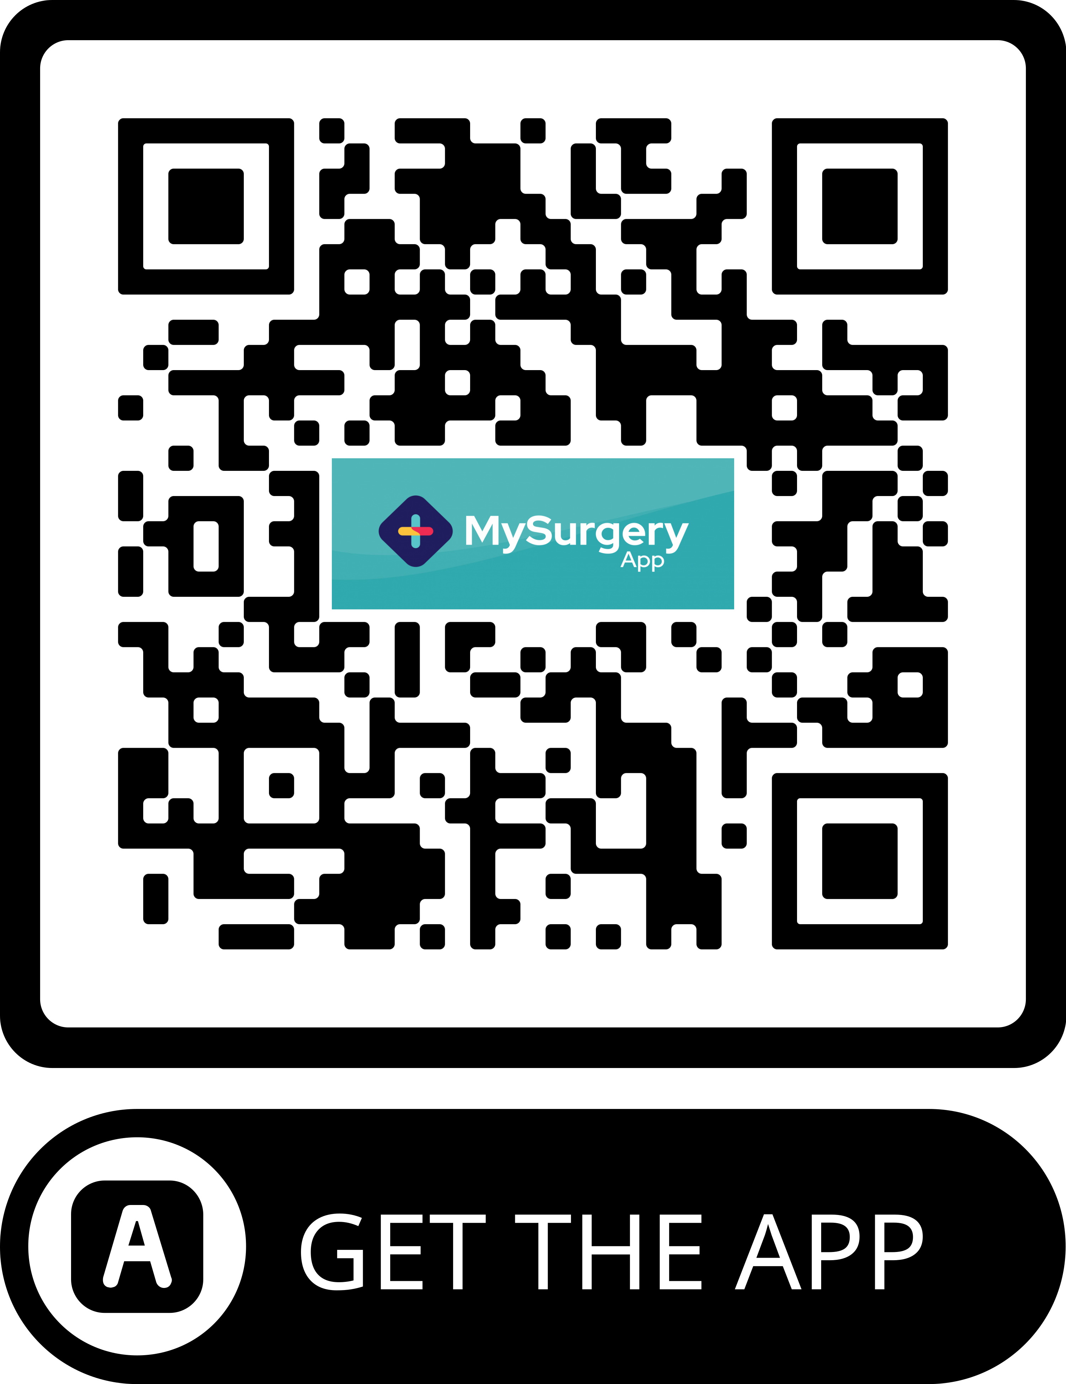

E-mail: practice.manager.W95012@wales.nhs.uk

Welcome to the Woodlands Surgery Group Practice:

This booklet has been designed to help you to access the services offered by the Practice. Please read it carefully, and keep it in a safe place for reference when you need it.

Although you have today registered with one doctor in the Practice, we do not insist that patients see only that doctor. You are free to make an appointment with any of the doctors in the Practice, to make the most of the particular expertise within the Partnership.

The doctors and staff of this Practice are committed to providing the best possible healthcare service. We can only achieve this goal by working with you in partnership in your care. As partners, we feel that we have responsibilities to each other. The main details of the Practice’s Patients Charter, which sets out the standards of service which we agree to provide, is listed below. In the spirit of the partnership we have entered into, it also sets out what we ask of you, in return:

 You will be treated as a partner in the care you receive - Help us to help you - being a partner means that we have responsibilities to each other.

 You will be treated as an individual and will be given courtesy and respect at all times, irrespective of your personal attributes or your health problems - We ask that you treat the Doctors and all Practice Staff with the same courtesy and respect.

 Following discussion, you will receive the most appropriate care, given by suitably qualified people. No care or treatment will be given without your informed consent - It is our job to give you treatment and advice. In the interests of your health, it is important for you to understand all the information given to you. Please ask questions if you are unsure of anything.

 You have a right to see your health records (subject to any limitations in the law), which will be kept confidential - These cannot just be handed over to you, they must be viewed with the Doctor responsible for your care.

 We will give you full information about the services we offer. Every effort will be made to ensure that you receive the information which directly affects your health and the care being offered to you - Please read our Practice booklet and other leaflets produced regarding Practice services. These will help you to get the best from the services we offer.

 People involved in your care will give you their names and ensure that you know how to contact them - Please let us know if you change your address or name. Please let us have your telephone number.

Practice Area:

This Practice accepts patients living within the boundary of Maesteg as shown outlined on the map detailed below. Patients who move further afield may be asked to register with another doctor in their home area. We do not accept patients with an SA13 post code.

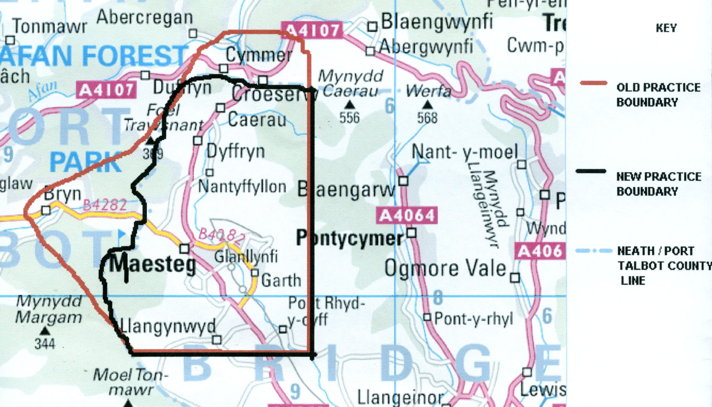

The practice is situated in Woodlands Terrace, Caerau, (CF34 0SR), just off the A4063. We can be accessed by using the First bus service, bus number 32 or 36, getting off at Caerau Square. Unfortunately, there is no dedicated patient car parking area.

Registration with the Practice:

To register with the practice, patients are required to complete a Registration Form and a New Patient Questionnaire. The application is processed and the patient will be contacted and offered a New Patient Examination with the Practice Nurse or Health Care Assistant.

Disabled Access:

The surgery premises offer purpose built accommodation, which caters for the needs of the disabled (to include ramp access, wide entrance doors and toilet facilities). Unfortunately no disabled car parking facilities exist. A hearing loop system is also available.

In addition a number of practice produced literature is available in large print and every effort is made to make available information in different formats, as required. We recognise that a high proportion of our patients, their families or carers may be disabled and we respectfully ask that you inform practice staff of any specific access requirements that are needed in order to use our services.

Primary Care Team:

The following people work at Woodlands Surgery and make up the Primary Care Team:

Mrs Karen Smith | Practice Manager
Mrs Clare Lewis | Assistant Practice Manager

Clinical Staff:

Dr Geoff Smith | Male | MB BS Dip RDM PC Senior Partner/Clinical Governance Lead, Bridgend North Cluster Lead
Dr Jonathan Jones | Male | MB Bch
Dr Heather Cottrell | Female | MBBCh (Hons) DRCOG DFFP MRCGP (Merit) LoC IUD
Dr Sadagopan Sasirekha | Female | MBBS MRCGP, Msc Diploma in Psychological Medicine, PG Cert., in Management

Nurses:

Sister Claire Wood | Advanced Nurse Practitioner
Sister Hannah Evans | RGN
Sister Amy Maynard | RGN
Rebekka Lewis | Phlebotomist / Health Care Assistant
Rachel Ray | Phlebotomist / Health Care Assistant
Lisa Watkins | Phelbotomist / Health Care Assistant
Sister Karen Smith | RGN DIP (H&SW) BSC (HONS) SPEC PRACTITIONER Independent Prescriber
Clerical Staff:

1 Secretary:  Angela Tidball | Providing secretarial support for the Practice in hospital referrals and other correspondence.
1 Administrator:  Sharon Phillips  Davina Wood | Responsible for general administration, data entry and for maintaining medical records in good order.
4 Reception Staff:  Elaine Morgan (Senior Receptionist)  Rebekka Lewis  Amber Wood  Bethan Davies  Lianne Thomas  Rachel Ray | These staff members make appointments for practice services, handle repeat prescription requests and all telephone calls.

Attached Staff:

In addition to the above staff, the following community nursing staff are attached to the Practice and work with Doctors and Practice nursing staff in providing patient care:

District Nurses | Who, by arrangement with your GP or hospital doctor, will provide nursing support at home for the sick or housebound.  District nurses can be contacted on telephone number (01656) 753922
Health Visitors | Who are able to help with health matters relating to the under 5's, disabled and elderly patients.  Health Visitors can be contacted on telephone number (01656) 815153
Midwifery Team | Working with the Practice to provide care for mothers before and after delivery of their babies, and care for baby in the first 2 weeks of life.  Telephone number (01656) 752752

Special Clinics and Services Available:

Child Health Surveillance: All partners undertake child health surveillance for children under the age of 5 years.

Minor Surgery: A minor surgery service is provided by Dr Smith.

Carers Register: The practice holds a register of all Carers and is proactive in offering help and support to all Carers on the register. Carers Champion is Clare Lewis

Veterans Register: The practice holds a register of all Military Veteran patients. Please advise us if you have served in the armed forces, this may entitle you to priority treatment for any condition related to your time in service.

The Homeless Person: The practice holds a register of homeless patients to offer help and support.

Weight Management Clinic: The Practice Nurses are available to discuss weight management.

Mental Health Clinic: Weekly Specialist Mental Health Nurse lead clinics at the surgery.

The Practice also offers the following clinic services to patients by appointment:

CHD  (Coronary Heart Disease / Angina) | Advice and regular progress checks for those patients that have been diagnosed with CHD.
Smear Clinic | Clinic run by the Practice Nurse
Hypertension Clinic | To monitor those patients whose GPs feel that regular checks on their blood pressure is necessary
Asthma Clinic | Advice and regular progress checks for those who have particular problems with asthma
Minor Surgery | Your doctor may ask one of the Partners in the Practice who undertake minor surgery, to see you about your problem, to see if treatment can be given in the surgery, rather than hospital
Diabetic Clinic | Advice and regular monitoring for those with diabetes, and screening and advice for close relatives of patients with this condition. The clinic also has the benefit of a dietician in support.
Coil Clinic | Regular clinics are held for ladies wishing for a coil insertion.

The Practice also runs a number of other specialist clinics for the monitoring of particular illnesses or conditions, which are not listed here. Your doctor will advise you about these if they would be of benefit to you.

How To See The Doctor:

Receptionist Telephone availability

Monday to Friday | 8.00am - 6.30pm

Receptionist Face to face availability

Monday to Friday | 8.30am - 6.30pm

The surgery operates an open access appointment system in the mornings. If you feel unwell on the day, please ring after 8.00am to request an appointment with one of the doctors (not of your choice) that same morning. The receptionist will give you a time to come in to surgery. Upon your arrival you will be seen by the next available doctor. When the allocated slots are filled for the morning, any patient needing to be seen will be assessed by the nurse and dealt with appropriately. It is not possible for you to see a

particular doctor of your choice, so please do not make a specific request. Booked appointments, with a doctor of your choice (subject to availability), can be made for an afternoon surgery. Waiting times for an these appointments vary according to the doctor you choose to book with. Please telephone the surgery or call in to speak to a receptionist.

On occasion, due to unforeseen circumstances and emergencies, surgeries will run late and you will therefore not be seen at the time you were given. If this should occur, patients will be informed of the approximate delay.

Please make every effort to keep the appointments you have arranged and arrive promptly at your given time, in order for us to maintain smooth running of the practice. If you no longer need the appointment, telephone us as soon as possible, to enable the appointment to be offered to another patient or cancel via our website. Appointments made via MHOL can be cancelled using MHOL also.
If you are late for an appointment, it may not be possible for your doctor to see you when you arrive, and you may be asked to make another appointment.

Please note that the surgery is closed for training on the last Tuesday afternoon of every month. During this time you can contact an emergency doctor by telephoning the surgery as normal, where you will hear an answer phone message giving you a number to call.

If you require telephone advice from:

Doctor | 11.30am - 12 noon | 01656 734203
Practice Nurse | 12noon - 1.00pm | 01656 734203

These are approximate times and a more realistic time to contact the doctor or nurse will be given by the receptionist when you first call, based on how smoothly the surgery is running on that particular day. Alternatively the Practice Nurse is available for face to face consultation during surgery hours.

Home Visits:

If you need to see the doctor, but feel too ill to come to the surgery or are housebound, please wherever possible, make your request for a visit before 10.00am. This will enable the doctor to plan his rounds more effectively. The receptionist will ask you for details of your name, address, telephone number and age. She will also ask you for some idea of your problem. This information is needed by your doctor to establish who needs to be visited first. Home visits are for the terminally ill, elderly housebound and for those patients where medically justified. Home visits are at the discretion of the doctors and are not an automatic right and will not be entertained on social grounds (eg. lack of transport). All children should normally be brought to the surgery.

FOR HOME VISITS WHICH ARE URGENT
PLEASE TELL THE RECEPTIONIST WHEN GIVING THE PATIENT’S DETAILS.

Out Of Hours Services:

Out of hours services are for patients who need to see a doctor for problems which cannot wait until the surgery reopens. The service is operated by the South East Wales GP OOH Service, a local healthcare provider experienced in providing care outside normal surgery hours. Out of hours services operate during the following times:

Monday – Thursday: 6.30pm – 8.00am
Weekends: 6.30pm Friday until 8.00am Monday

The service will also be available on Bank Holidays

To contact the out of hours service, ring 111. A trained call handler will answer your call and take some personal details and basic information about the problem. They will advise you on the most appropriate care or offer you an appointment at the local Primary Care Centre (Princess of Wales Hospital or Neath Port Talbot Hospital). Attendance at the Primary Care Centre is by appointment only.

A 24hr nurse-led advice line is provided free of charge by NHS Direct Wales on Tel: 0845 46 47 or www.nhsdirect.wales.nhs.uk or by ringing 111.

If you have a severe injury or a serious accident you should dial 999.

Repeat Prescriptions:

Repeat prescriptions are authorised only by your doctor, and are for 1 month’s supply of medication at a time. You doctor will wish to review your condition at regular intervals, and you will be asked to see a doctor every few months to monitor your progress.

Requests for Repeat Medication:

Requests for repeat prescriptions can be made as follows:

- Telephone requests for repeat prescriptions are taken by the local Prescribing Hub on telephone number: 01656 311010
Mon – Fri 9am – 5pm (excluding Bank Holidays)

2) By post - enclosing your request slip together with details of which pharmacy you wish your prescription to go to or a stamped addressed envelope

3) By hand - you may leave your request slip in the box provided in the surgery (see below)

4) Using the On-line ordering system (see below)

PLEASE NOTE: 48 working hours notice is required to process repeat prescriptions.

Please indicate clearly in the tick-boxes which items of medication you need, to avoid the unnecessary prescribing of items you use only infrequently. Your request cannot be dealt with until you do this. If you use a pharmacy in Maesteg, you may write on

the slip the name of the pharmacy you wish your prescription to be sent to if you wish to avoid your having to return to the surgery to collect it.

On-Line Services

Appointments and prescriptions can be arranged via the NHS Wales ‘My Health On-Line’ service. MHOL is part of a Welsh Assembly Government initiative to improve patient care through better use of IT and information. Registration forms can be requested from a receptionist. Please bring along your photographic ID.

Test Results and General Enquiries:

The surgery is always extremely busy during the morning sessions, because of the volume of requests for appointments and home visits which are made at that time. Test results arriving on that day are only reviewed by doctors after their surgery session, and may not be available until later in the day. Your doctor will have given you some idea about how long the results of your tests are likely to take. Some tests need only a day or two, whilst others make take several weeks. It will help us both, therefore, if you could avoid telephoning the surgery too soon for results of tests and try and ring between 12.30pm and 3pm to obtain the results on the day you call.

Patients’ Comments:

We welcome patients’ views on the running of the Practice and the services which it offers, both good and bad. If you have any comments or suggestions, please make them in person to one of the Receptionists or in writing, either to one of the doctors or to the Practice Manager.

Complaints:

The Practice operates its own complaints procedure. Details are given more fully in a leaflet available from reception staff. Minor complaints may be dealt with quickly by addressing these to the receptionist on duty, who may be able to solve the problem for you. More serious complaints, and those involving any clinical matter, should be addressed to the Practice Manager. In addition Community Health Council leaflets are available in the waiting area.

Violent and Abusive Behaviour:

The practice runs a Zero Tolerance policy towards Violent and Abusive behaviour by patients towards Doctors or Staff. Patients who are abusive may be reported to the Local Health Board and asked to leave the practice list.

Freedom of Information Act:

The Practice has a publication scheme which details the information it routinely makes available for patients. A copy of the scheme is available from the receptionist.

Details of primary care services in the area may be obtained from:

Cwm Taf Morgannwg University Health Board
Ynysmeurig House, Navigation Park, Abercynon, Rhondda Cynon Taf
CF45 4SN

Tel. No. 01443 744800

Medical Students:

We are an approved teaching practice for undergraduate medical students from Cardiff University and graduate students from Swansea University. We look forward to your co-operation in the training of future doctors. Please note that the students are bound by the same code of medical ethics (including that of confidentiality) as the staff and doctors at the practice. However, should you rather not have students present during the consultation please let us know and your wishes would be respected; rest assured that your care would not be compromised and you would continue to receive the same high standard of care in the case of your non-participation in teaching activities.

GP Trainee / Registrars:

We are an approved teaching practice for GP Trainees (or Registrars as they are sometimes known). The Trainee will be attached to one of the doctors here who is their trainer. The GP Trainee is a fully qualified doctor who is likely to have a lot of experience of hospital medicine and who are now training to become a General Practitioner (GP).

Personal Health Information

No Personal Health information is disclosed to any third party without the appropriate prior consent of the patient.

IN A MEDICAL EMERGENCY

- In a severe emergency such as breathing difficulties, severe bleeding or stroke – ring 999.
2. Telephone the surgery and advise the Receptionist that a doctor is required. Be prepared to tell the Receptionist details of the patient’s problem to help your doctor to decide if an ambulance is necessary.
2. Outside normal surgery hours, a recorded message will give you the telephone number of the Out of Hours Service Provider - it will help if you have a pen and paper ready.
3. Please give FULL details to the Answering Service - the staff there are specially trained and will give appropriate advice. In certain circumstances, a paramedic and ambulance will be sent at the same time.
4. If you need to call your doctor at night, please make sure that your house shows a light and an easily read name or number, to help the doctor find you. If your home is difficult to find, please give full, clear directions.

THIS PRACTICE OFFERS A SCREENING PROGRAMME FOR ALL
PATIENTS, IN PARTICULAR FOR:

 If you have recently registered, you are invited to make an appointment for health screening. Please ask the reception staff to make this appointment for you.
 If you are a woman aged 25-64 years, and have never had, or are overdue for a cervical smear test, please notify the nursing staff without delay.
- If you are over 75 years of age, you are entitled to an annual check-up. If you have not had a specimen of urine tested in the past year, please bring one with you when you next attend the surgery or have one available for your doctor if you require a home visit. We will make every effort to make sure you have had your check-up, but please let us know if you think you have been missed out.

Please use this space to make comments/suggestions about any aspect of the practice. (Please cut out and hand in at reception)

